

American International University-Bangladesh

Project Report

# Safety System Using Fire Alarm with Flame, Gas Sensor and Water Sprinkler

**Course: MICROPROCESSOR AND EMBEDDED SYSTEMS**

**Section: G**

Submitted to: TAHSEEN ASMA MEEM

**Submitted by:**

**Shome, Shourav**

ID: 18-36939-1

**Dohan, Din Mohammad**

ID: 17-34465-2

**Faiaz, Ben Reza**

ID: 18-36655-1

**Ety, Rabeya Aktar**

ID: 18-36963-1

**Choya, Sumaya Binte Zilani**

ID: 18-36235-1



**Organization of the Chapters**

1. Introduction **3**
   1. Abstract 3
   2. State of the Arts 3
   3. Motivation 3
2. Literature Review **4**
3. Methodology and Modeling **6**
   1. Introduction 6
   2. Working principle of the proposed project 6
   3. Description of the important component 6
   4. Implementation 8
   5. Measurement/Test Setup 8
   6. Cost Analysis 11
4. Results and Discussion 11
   1. Simulation 11
   2. Experimental Results 14
   3. Comparison between numerical and experimental results 15
5. Impact of professional engineering solutions on society and environment **16**
6. Conclusion **16**
7. References **17**

# Introduction Abstract:

Fire incident is a disaster that can potentially cause the loss of life, property damage and sometimes permanent disability to the victim. If fast attempt is not taken to put out the fire, then it can cause some serious accident even life loss. So, we aim to design such system that is capable of detecting and suppressing fires. By designing and implementing a system capable of detecting and surpassing fires disasters can be avoided with minimal risk to human life. The main purpose of this paper is to demonstrate the simulation and implementation of a system to automatically detect gas or smoke resulting in fire and start to sprinkle water as primary act of fire fight before additional rescue takes place. 2 basic sensors were used to detect fire and gas. These sensors can automatically sense the fire and smoke and that alerts human with a buzzer and starts sprinkling water to stop the flame from spreading.

***Keywords****— Flame sensor, Gas sensor, Arduino Uno, Water Sprinkler.*

# State of the Arts:

Fire is the state of combustion which inflammable materials burn producing heat, flames and often smoke. It can be destructive and uncontrollable causing loss of life and property. Recently fire incidents occurrence in Bangladesh grew much more because of some faulty measures and instrumental design flaws in Bangladesh. It is often seen in different news reports about fire incidents such as fire occurrence because of gas leakage from cylinder. The latest tragedy is that four people have died, and 20 people have been injured, in a fire in Gazipur, after a cooking gas cylinder exploded at a colony of apparel workers in Kaliakair upazila. As many as 50 households were affected in the fire. [1]

Also sometimes, it is seen that fire starts from different electrical faulty products like air condition. And at times, it is difficult for fire fighters to come to the destination at time and often fire spreads fast before arrival of fire fighters. If some primary steps can be done by the very start of a gas leakage or fire, then the destruction can be kept to a minimal state. Often a little gas leakage can be noticed by human which later causes a great fire. In large corporate spaces it is hard to notice a small gas leakage or fire from any faulty electrical machines. An automated fire safety system can help us a lot in this kind of situations.

# Motivation:

Now a days everything is automated to reduce human effort. So, in case of fire incidents while humans will be busy evacuating the place the fire safety system can also reduce spread of fire by water sprinkler. In this paper we proposed a fire safety system which will detect fire and gas automatically, make warning sound by an alarm and depending on situation it will automatically start sprinkling water on that place. This will help human by controlling the fire to certain level

that humans can evacuate themselves and also reduce the damage of property. This system will work automatically without any human intervention. So, in cases of fire incident where no people is around this system will be of great use as this also has an alarm system to notify or warn people staying near-by.

# Literature Review

1. Intelligent Residential Security Alarm and Remote Control System Based on Single Chip Computer: LIU zhen-ya et al, ( 2008):



The paper focuses on, Intelligent residential burglar alarm, emergency alarm, fire alarm, toxic gas leakage remote automatic sound alarm and remote control system, which is based on 89c51 single chip computer. The system can perform an automatic alarm, which calls the police hotline number automatically. It can also be a voice alarm and shows alarm occurred address. This intelligent security system can be used control the electrical power remotely through telephone (Forzani et al, 2009).

1. Design and implementation of Remote International Journal of Engineering Research and General Science Volume 5, Issue 1, January-February, 2017 ISSN 2091-2730 217 [www.ijergs.org](http://www.ijergs.org/) Monitoring System Based on GSM: Chen et al, (2008)



This paper focuses on the wireless monitoring system, because the wireless remote monitoring system has more and more application, a remote monitoring system based on SMS through GSM. Based on the overall architecture of the system, the hardware and software architecture of the system is designed. In this system, the remote signal is transmitted through GSM network. The system includes two parts which are the monitoring center and the remote monitoring station. The monitoring center consists of a computer and a TC35 communication module for GSM. The computer and the TC35 are connected by RS232. The remote monitoring station consist of a TC35 communication module for GSM, a MSP430F149 MCU, a display unit, sensors and a data gathering and processing unit. The software for the monitoring center and the remote monitoring station were designed using VB (Geng et al, 2007).

1. A New Approach of Automatic Localization System Using GPS and GSM/GPRS Transmission: Lita et al, 2006



This paper focuses on, a low cost automotive localization system using GPS and GSM- SMS services, which provides the position of the vehicle on the driver’s or owner’s mobile phone as a short message (SMS) on his request. The system can be interconnected with the car alarm system which alerts the owner, on his mobile phone, about the events that occurs with his car when it is parked. The system is composed by a GPS receiver, a microcontroller and a GSM phone. In additional the system can be settled for acquiring and transmitting the information, whenever requested about automobile status and alerts the user about the vehicle started engine. The system can be used as a low cost solution for automobile position localizing as well as in car tracking system application.

1. Investigation of gas sensors for vehicle cabin air quality monitoring: Galatsis et al, (2002) This paper focuses on, car cabin air quality monitoring can be effectively analyzed using Metal Oxide Semiconducting (MOS) gas sensors. In this paper, commercially available gas sensors are compared with Fabricated Moo3 based sensors possessed comparable gas sensing properties. The sensor has response 74% higher relative to the host commercial sensor tested
2. Intelligent Smoke Alarm System with Wireless Sensor Network Using ZigBee: Volume 2018



This paper introduces an intelligent smoke alarm system that uses ZigBee transmission technology to build a wireless network, uses random forest to identify smoke, and uses E- charts for data visualization. By combining the real-time dynamic changes of various environmental factors, compared to the traditional smoke alarm, the accuracy and controllability of the fire warning are increased, and the visualization of the data enables users to monitor the room environment more intuitively. This system consists of a smoke detection module, a wireless communication module, and intelligent identification and data visualization module.

1. Design and Implementation of a Smart Home (Smoke, Fire, Gas and Motion Detector) Volume: 05 Issue: 08 (2018)



This paper focuses to Design a Gas, smoke, fire and motion detector with SMS alarm for house, office, and shop security utilizing uninvolved derived pyroelectric (PIR) movement locator either the owner is at home or not. The importance of this project is to give an alert when there is leakage of Gas, detection of smoke, fire and motion (intrusion) via SMS. It helps to enhance safety. At the end of this project, the result “fire detected, smoke detected, gas leakage detected, and motion detected was achieved”. Smart homes will one day be the manner in which all homes are lived in. This anyway will require some investment. Like the presentation of power in the turn of the century, the shrewd domestic undertaking needs time to develop before it winds up standard. There are, in any case, numerous advantages to owning a smart home because of the security and accommodation it can give.

# Methodology and Modeling Introduction:

Microcontroller is an open-source platform used for creating interactive electronics projects. In this project we use microcontroller to make such a project that is cheaper and also simple to use by different type of users. To construct this project, we are using different type of component such as Microcontroller, Flame Sensor, Gas Sensor, Buzzer, DC Motor, LED Light, L293D, Resistor, Switch, Voltage Supplier and Ground.

# Working Principle of Proposed Project:

In our project, we used flame sensor and gas sensor to detect smoke and fire. If set on fire anywhere in home, then it will be alarmed with blinking red light about the danger environment will be displayed on the Virtual Terminal. After that, water pump will pump water and sprinkler will try to extinguish the fire and if smoke is detected in the home then it will be also alarmed and yellow light will be blinked as a result living person will take action and they will stay safe in the home.

# Description of the important component:

## Gas Sensor (MQ-2)

The MQ series of gas sensors use a small heater inside with an electro-chemical sensor. They are sensitive for a range of gasses and are used indoors at room temperature. The MQ-2 Gas Sensor module is useful for gas leakage detecting in home and industry. It is highly sensitive in the detection of the presence of gases in the air such as LPG, propane, methane, hydrogen, alcohol, smoke and carbon monoxide. It is commonly an unwanted by-product of fires. Smoke Detectors are very useful in detecting smoke or fire (GAS) in buildings, and so are the important safety parameters. The smoke sensor detects smoke and provides output to the MCU.MQ2 gas sensor is also known as Chemi-resistor. It contains a sensing material whose resistance changes when it comes in contact with the gas. This change in the value of resistance is used for the detection of gas. Some modules have a built-in variable resistor to adjust the sensitivity of the sensor. It was used in this project for the detection of LPG and smoke in home. The sensor and it configuration is shown in the fig below.

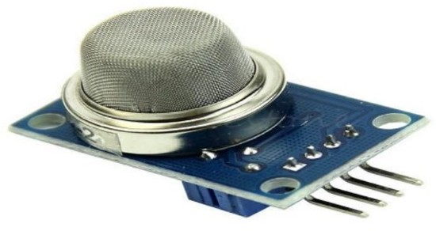

Fig: MQ-2 Sensors

## Flame sensor

A flame-sensor is one [kind of detector](https://www.elprocus.com/emf-detector-circuit-working-types-and-its-applications/) which is mainly designed for detecting as well as responding to the occurrence of a fire or flame. It includes an [alarm system,](https://www.elprocus.com/fire-alarm-circuit-using-thermistor/) a natural gas line, propane & a fire suppression system. This sensor is used in [industrial boilers.](https://www.elprocus.com/what-is-steam-boiler-working-principle-types-of-steam-boilers/) The main function of this is to give authentication whether the boiler is properly working or not. The response of these sensors is faster as well as more accurate compare with a heat/smoke detector because of its mechanism while detecting the flame. This sensor/detector can be built with an [electronic circuit](https://www.elprocus.com/top-10-simple-electronic-circuits-for-beginners/) using a receiver like electromagnetic radiation. A flame detector is a sensor designed to detect and respond to the presence of a flame or fire. This sensor/detector can be built with an electronic circuit using a receiver like electromagnetic radiation. This sensor uses the infrared flame flash method, which allows the sensor to work through a coating of oil, dust, water vapor, otherwise ice.

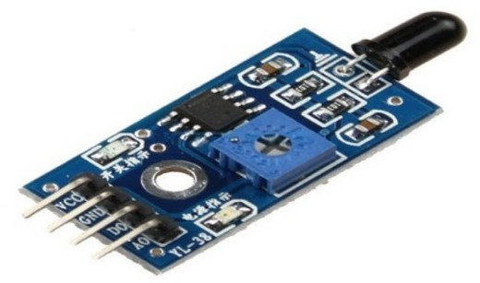

Fig: Flame Sensor

## Pin Configuration of Flame Sensor

Flame Sensor includes four pins which include the following. When this module works with a microcontroller unit then the pins are

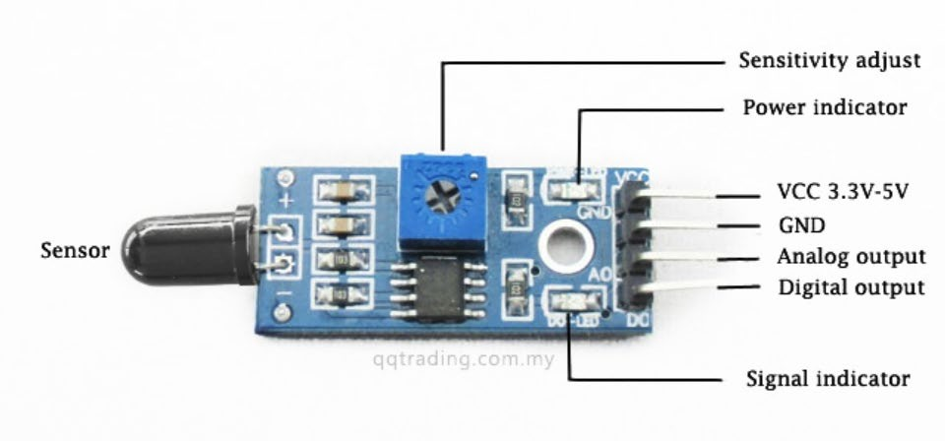

## Fig: Pin Configuration of Flame Sensor

* + Pin1 (VCC pin): Voltage supply rages from 3.3V to 5.3V
  + Pin2 (GND): This is a ground pin
  + Pin3 (AOUT): This is an analog output pin (MCU.IO)
  + Pin4 (DOUT): This is a digital output pin (MCU.IO)

## 4. L293D

1. L293D is a Motor driver integrated circuit which is used to drive DC motors rotating in either direction.
2. It is a 16-pin IC which can control a set of two DC motors simultaneously. It means that we can control two DC motor with a single L293D IC.
3. Dual H-bridge Motor Driver integrated circuit(IC). The L293D uses 5V for its own power and external power source is needed to drive the motors, which can be up to 36V and draw up to 600mA.

This IC can set up motors with a voltage between 5V to 36V and a current of up to 600 mA. However, it can withstand a current up to 1200 mA in 100 microseconds and non- repetitive. The frequency of this IC is 5 kHz. The L293D is designed to provide bidirectional drive currents of up to 600-mA at voltages from 4.5 V to 36 V. Both devices are designed to drive inductive loads such as relays, solenoids, DC and bipolar stepping motors, as well as other high current / high voltage loads in positive supply applications. Each output is a complete totem-pole drive circuit, with a Darlington transistor sink and a pseudo- Darlington source. Drivers are enabled in pairs, with drivers 1 and 2 enabled by 1,2EN and drivers 3 and 4 enabled by 3,4EN. L293D is characterized for operation from 0°C to 70°C.

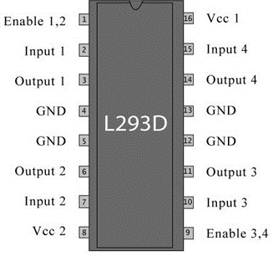

# Implementation:

First, we take different type of component such as Arduino Uno R3 Board, flame sensor, MQ6 Gas sensor, Buzzer, DC Motor, LED Light, L293D, Resistor, Switch, Voltage Supplier etc. After that we connect flame sensor to Microcontroller pin A0 (this type of pin used as ADC) and also, connect gas sensor to Microcontroller pin A3 then we connect ground in the flame and gas sensor. After that, we take DC Motor which works as a sprinkler then connect it with microcontroller pin and take simple motor that works as a water pump. This motor connected to L293D which is basically motor driver, then connect it with microcontroller pin. Then after, we make a connection between LED Light and resistor through digital pins in the microcontroller. We connect buzzer as well as for warning purpose Finally, we connect virtual terminal to control the display output result.

# Test setup:

The main purpose of this project is to detect fire and smoke and warn it using fire alarm and then extinguish fire using sprinkler and keep home safe.

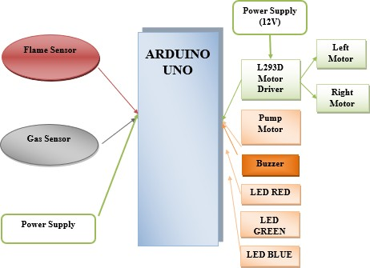

Figure.1. Block Diagram

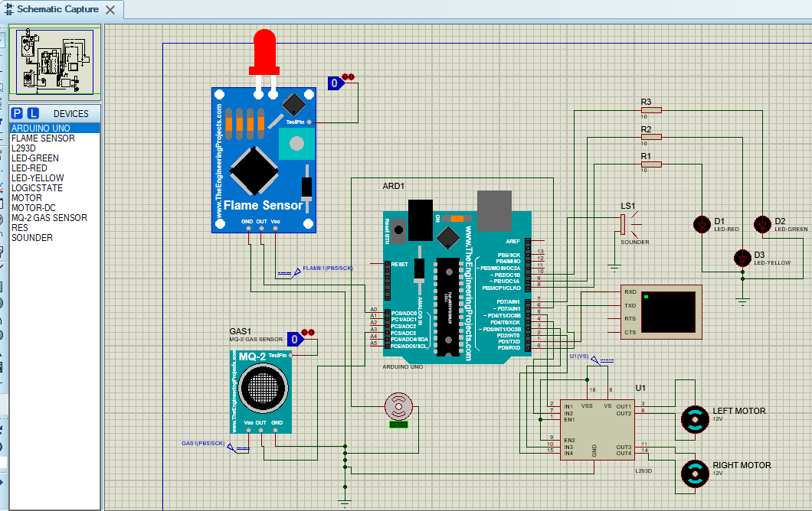

Figure.2. Simulation Circuit

We connect flame sensor to analog pin A0, Analog type pin used as an ADC in this system. Also connect gas sensor to analog pin A3 to the micro-controller pin. We connect red, yellow, green light to the microcontroller pin 8,9,10. These are the digital pin of micro-controller. Digital and Analog pins are used as an input and output pin. Between light and micro-controller, we add resistor. After that also connect buzzer to pin no 7 with micro-controller.

Here we connect motor with the micro-controller pin 6 which is digital pin also. Left motor and Right motor are also connected to motor driver and this motor driver is attached with controller.

By connecting virtual terminal with the micro-controller it shows the output result. By default, it shows “Safe Environment”. When only fire is set then red light blinked and alarm it, then it shows “Fire Detected: Danger” and when only smoke is detected then yellow light is blinked and it shows “Smoke Detected: Warning”. If both situation is occurring, then it shows “Fire and Smoke Detected: Danger” on the virtual terminal screen.

In above simulation circuit and paragraph, we show the test setup of this project and overall working principle of this circuit. The overall setup is fulfilled as our proposed system and requirement.

# Cost Analysis:

|  |  |  |  |
| --- | --- | --- | --- |
| **Serial** | **Product Name** | **Quantity** | **Price (TK)** |
| 1 | Arduino Uno R3 | 1 | 680.00 |
| 2 | Flame Sensor | 1 | 88.00 |
| 3 | MQ6 Gas (Gas Sensor) | 1 | 149.00 |
| 4 | Buzzer | 1 | 15.00 |
| 5 | Resistor | 3 | 3*28.00= 84.00 |
| 6 | DC Motor | 2 | 2*200.00= 400.00 |
| 7 | LED Light | 3 | 3*15.00= 45.00 |
| 8 | L293D (Motor Driver) | 1 | 200.00 |
| 9 | Modulo TX | 1 | 150.00 |
| 10 | Motor (Sprinkler) | 1 | 80.00 |
| **Total Cost** | | | **1891.00** |

**Result and Discussion: Simulation:**

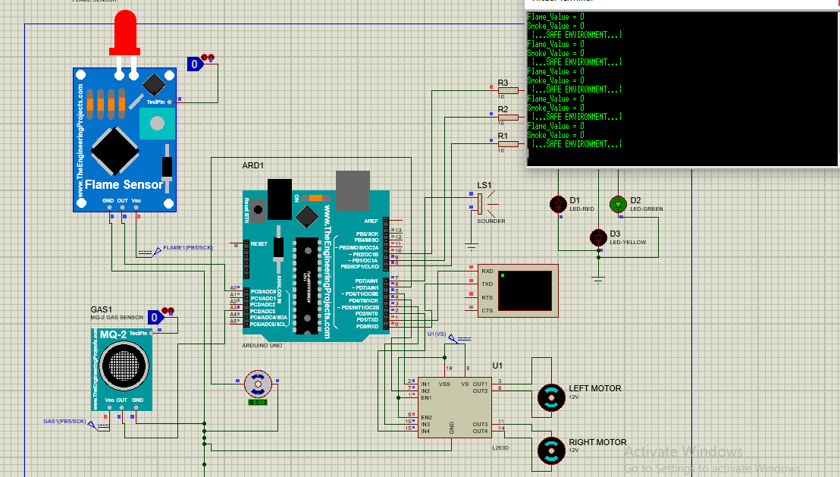

**Figure: Flame value and Smoke value 0**

Here we can see that, Flame value=0 Smoke value=0

In this stage we will get a message in our virtual terminal that “Safe Environment” that means our environment is safe. And as we get safe environment our green light will show up.

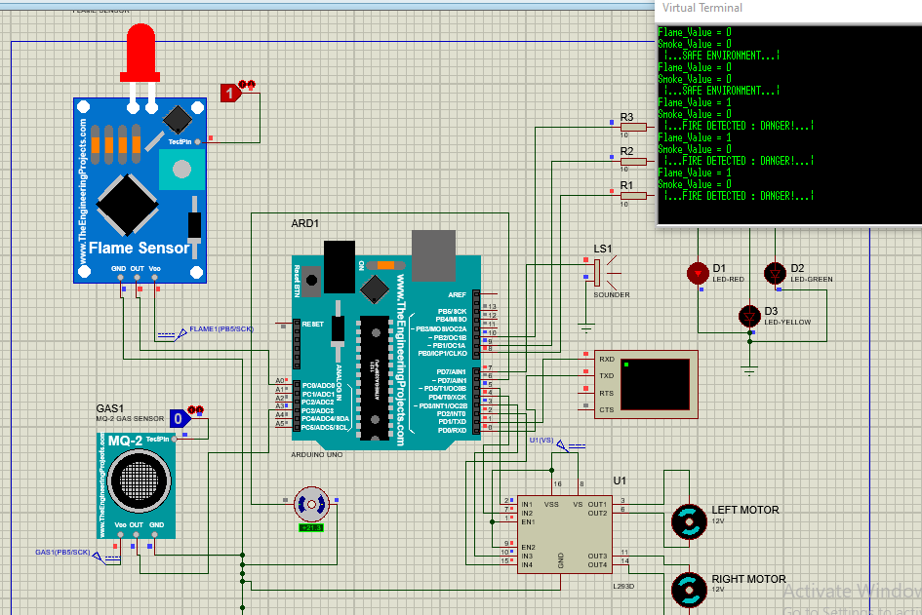

**Figure: flame value 1 and smoke value o**

Here in this part we can see that, Flame value=1

Smoke value=0

In this stage we will get a message in our virtual terminal that “Fire Detected” that means our environment is not safe. So that red light will show up. Then left motor and right motor will start to pump water. And the sprinkler will star to distinguish the fire until it turns off.

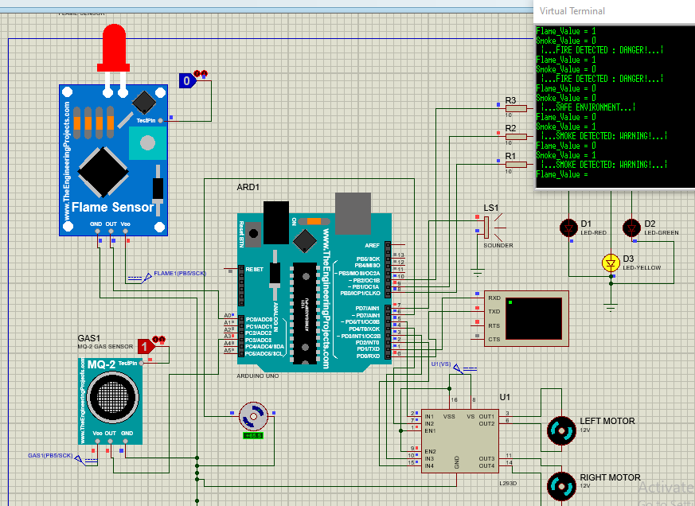

Fig: flame value as o and smoke value as 1

Here in this stage flame value = 0 and smoke value =1

So that we will get a message in the virtual terminal that the “Smoke Detected” and also the environment will be in danger mode. For that yellow light only turn on.

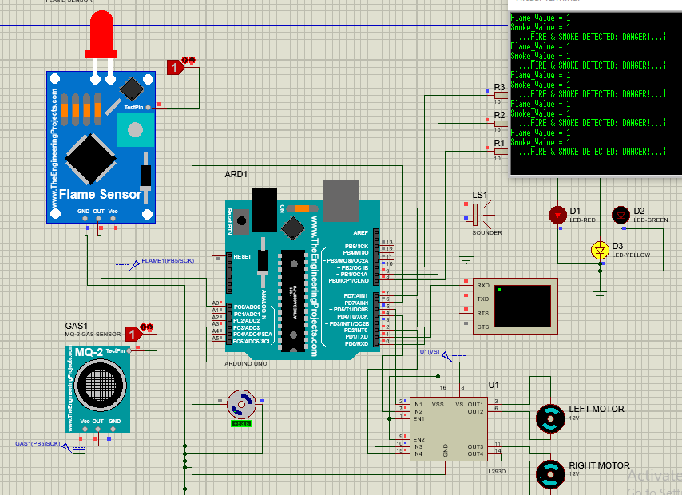

Fig: Flame value as 1 and Smoke value as 1

In this final part we will get flam and smoke value both as 1, then the messages show in the terminal that the environment will be in danger mode. The Red LED and Green LED both will turns on.

# Experimental Results:

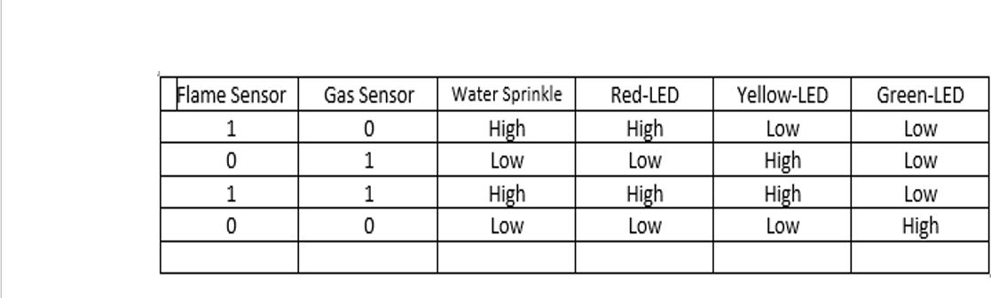

In our experimental data we see that exactly we get the results according to our expectation.

* We get Red light high when only flame value is 1 and smoke value is 0
* We get yellow light high only when smoke value is 1 and flame value is 0
* We get Green light high when the smoke and flame both value is 0
* We get Red and Yellow light high when we get flame value 1 and smoke value 1

# Comparison Between numerical and experimental results

In this project that we have implemented matched our expectation with numerical data. Though we do not have any exact numerical data because this machine is not available as a whole in the market.

So the data we assumed to be correct is our numerical data. That is shown below:

|  |  |
| --- | --- |
| Environment | Flame value, Smoke Value |
| Safe | 0, 0 |
| Smoke Detection(Danger) | 0,1 |
| Fire Detection (Danger) | 1,0 |
| Smoke and Fire Detection(Danger) | 1,1 |

Figure: Numerical Data

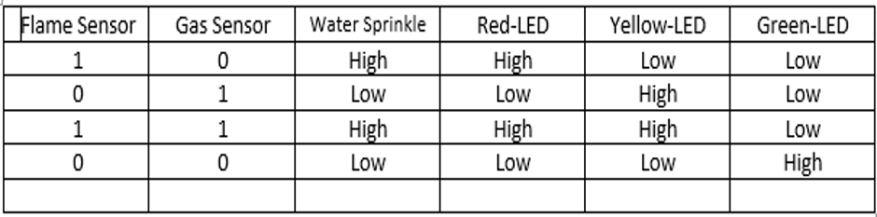

Figure: Experimental data

So, comparing both data from Experimental and Numerical we see that,

We have achieved our goal from the numerical value and we have successfully got our outputs exactly like the data we have got from numerical values.

**Implementation Code:**

/*-------defining Inputs------*/

int flame_S = A0; // flame sensor

int Smoke_S = A3; //smoke sensor

/*-------defining Outputs------*/

int LM1 = 2; // left motor

int LM2 = 3; // left motor

int RM1 = 4; // right motor

int RM2 = 5; // right motor

int pump = 6; // pump

int Buzzer = 7; // buzzer

int redled = 8; // fire signal

int yellowled = 9; // yellow led

int greenled = 10; // green led

void setup()

{

pinMode(flame_S, INPUT);

pinMode(Smoke_S, INPUT);

pinMode(LM1, OUTPUT);

pinMode(LM2, OUTPUT);

pinMode(RM1, OUTPUT);

pinMode(RM2, OUTPUT);

pinMode(pump, OUTPUT);

pinMode(Buzzer, OUTPUT);

pinMode(redled, OUTPUT);

pinMode(yellowled, OUTPUT);

pinMode(greenled, OUTPUT);

Serial.begin(9600); // for terminal, max 9600 bit pass, baud value

}

void loop()

{

int flameval1 = digitalRead (flame_S) ;// read input value

int smokeval = digitalRead(Smoke_S);

Serial.print("Flame_Value = "); // show in terminal

Serial.println(flameval1);

Serial.print("Smoke_Value = ");

Serial.println(smokeval);

if (flameval1 == LOW and smokeval == LOW) //If Fire OR Smoke not detected

{

Serial.println(" |...SAFE ENVIRONMENT...| ");

digitalWrite(LM1, LOW);

digitalWrite(LM2, LOW);

digitalWrite(RM1, LOW);

digitalWrite(RM2, LOW);

digitalWrite(Buzzer, LOW);

digitalWrite(pump, LOW);

digitalWrite(redled, LOW);

digitalWrite(yellowled, LOW);

digitalWrite(greenled, HIGH);

}

else if (flameval1 == HIGH and smokeval == LOW) //If Fire detected

{

Serial.println(" |...FIRE DETECTED : DANGER!...| ");

digitalWrite(LM1, HIGH);

digitalWrite(LM2, LOW);

digitalWrite(RM1, HIGH);

digitalWrite(RM2, LOW);

digitalWrite(Buzzer, HIGH);

digitalWrite(pump, HIGH);

digitalWrite(redled, HIGH);

delay(200); // red blinking

digitalWrite(redled, LOW);

digitalWrite(yellowled, LOW);

digitalWrite(greenled, LOW);

}

else if (flameval1 == LOW and smokeval == HIGH) //If SMOKE detected

{

Serial.println(" |...SMOKE DETECTED: WARNING!...| ");

digitalWrite(LM1, LOW);

digitalWrite(LM2, LOW);

digitalWrite(RM1, LOW);

digitalWrite(RM2, LOW);

digitalWrite(Buzzer, HIGH);

digitalWrite(redled, LOW);

digitalWrite(yellowled, HIGH);

digitalWrite(greenled, LOW);

}

else if (flameval1 == HIGH and smokeval == HIGH) //If FIRE & SMOKE detected

{

Serial.println(" |...FIRE & SMOKE DETECTED: DANGER!...| ");

digitalWrite(LM1, HIGH);

digitalWrite(LM2, LOW);

digitalWrite(RM1, HIGH);

digitalWrite(RM2, LOW);

digitalWrite(Buzzer, HIGH);

digitalWrite(pump, HIGH);

digitalWrite(redled, HIGH);

digitalWrite(yellowled, HIGH);

digitalWrite(greenled, LOW);

}

delay(400); // terminal message delay

}

# Impact of professional engineering solutions on society and environment

This project concept can be developed into a useful system for the home, office, or even industry. If the system senses gas or fire, it will sound an alarm, alerting those nearby. Aside from that, depending on the situation, the system sends out different signals through LEDs. In addition, the system will submit alerts and switch on the water sprinkler. As soon as a fire or gas is detected, these features kick in. These features are capable of preventing large-scale fire or gas accidents. It has very low deployment and maintenance costs. Every year, a large number of people are injured or killed in fires. Many financial losses occur as a result of the same cause. However, fire suppression devices are only used in large offices or shopping centers because they are costly and difficult to find as a single unit, and not everyone can afford them. If we can manufacture this unit, it will be able to provide fire protection at a very low cost.

# Future Work:

It's just a proof of concept. Right now, we're making this prototype with a variety of tools. We would be able to transform it into a valuable commodity in the future. We can also integrate an SMS and GPS system to send alerts and coordinates to the user and a nearby fire station. We can also include sensors that will enable us to cut off the electricity supply. This also necessitates the device's complete reliance on the battery or other power sources. We can also render the system dust and water- resistant. Finally, we can turn this system into a robot that will have a more versatile solution.

# Conclusion

Finally, we can deduce that the technology has the ability to greatly improve our fire-fighting capabilities. Its early warning system and prompt action could prevent a number of accidents while also saving us money. It is capable of operating in situations where humans are unable to. It can fight the fire on a small scale, but by adding features, it can become more usable. Manufacturing it at a low cost will enable a large number of people to use it, as it is a good solution. Accidents can happen at any time and in any place. Preventing a major catastrophe by taking immediate steps and measures is possible. We're excited to continue working on this system in the future to improve its reliability and make it more useful.

# References

1. Dhaka tribune Safety should be a priority, not an afterthought.

https://[www.dhakatribune.com/opinion/editorial/2021/01/12/ed-safety-should-](http://www.dhakatribune.com/opinion/editorial/2021/01/12/ed-safety-should-)

1. A.K. Singh, and Harshit Singh, “Forest Fire Detection through Wireless Sensor Network using Type-2 Fuzzy System”, International Journal of Computer Applications,” vol 52– No.9, pp. 19-23, August (2012.)
2. Al-Abbass Y. Al-Habashneh, Mohamed H. Ahmed, and Taher Husain, “Adaptive MAC Protocols for Forest Fire Detection Using Wireless Sensor Networks ,” in proceeding of IEEE electrical and communication system engineering confrence’, (2009),pp.329-333.
3. Apeh S.T, Erameh K.B2 and Iruansi U. (2014) “Design and Development of Kitchen Gas Leakage Detection and Automatic Gas Shut off System”, Journal of Emerging Trends in Engineering and Applied Sciences (JETEAS).Scholarlink Research Institute Journals, pp. 222- 228.
4. `ArnoldoDíaz-Ramíreza, Luis A. Tafoyaa, Jorge A. Atempa, and Pedro Mejía-Alvarezb, “Wireless Sensor Networks and Fusion Information Methods for Forest Fire Detection,” in Science direct on Electronics Engineering and Computer Science ’, 2012, pp.69-79.
5. ArunKumar.G.A. Rajasekhar.K., Satyanarayana.B.V.V., and SuryanarayanaMurthy.K, “Implementation of Real time Detection of Gas leakage in Industries usingARM7 &Zigbee”, International Journal of Engineering Research & Technology, Vol .1, Issue 7, pp 1-4, Sep 2012.
6. Qin Wu , 1,2 Jiashuo Cao , 2 Chuang Zhou , 2 Ji Huang , 2 Zhuo Li,2 Shin-Ming Cheng , 1 Jun Cheng , 3,4 and Guanghui Pan2 ,“Intelligent Smoke Alarm System with Wireless Sensor Network Using ZigBee “,Wireless Communications and Mobile Computing, Volume 2018,

Article ID 8235127, 11 pages <https://doi.org/10.1155/2018/823512>

1. PHILIP KPAE, F .O.1, MACMAMMAH Michael2, EZEKIEL Nsikak D.3, WOJI Chigozinum T.4, ABUBAKAR Abdullahi5 & KPAA Friday O.N.6 , “Design and Implementation of a Smart Home (Smoke, Fire, Gas and Motion Detector)”, Volume: 05 Issue: 08 | Aug 2018

,[www.irjet.net,](http://www.irjet.net/) Department of Electrical/Electronic Engineering, Ken Saro Wiwa Polytechnic, P.M.20, Bori. Rivers State, Nigeria.